**Bahria University, Lahore Campus**

Department of Computer Sciences

Lab Journal 04

**(Spring 2021)**

|  |  |  |
| --- | --- | --- |
| Course: | **Data Communication and Networks Lab** | Date: |
| Course Code: | CEL - 222 | Max Marks: 10 |
| Faculty’s Name: | Dr. Khurram | Lab Engineer: Fakhra Batool |

Name: **ALI HASSAN** Enroll No: **03-135211-005**

Objective(s):

Understanding of generating analog, digital signal

## Lab Tasks:

***CODE:***

A=5;

time=0:0.001:1;

f1=20;

f2=5;

analog=A.*sin(2*pi*f1*time);

subplot(3,1,1);

plot(time,analog);

title('Message Signal');

grid on;

digtal=square(3*pi*f2*time);

subplot(3,1,2);

plot(time,digtal);

title('square pulses');

**Task 01**

**Generate Analog signal in Matlab.**

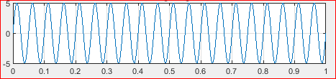

**Task 02**

**Generate discrete signal in Matlab.**

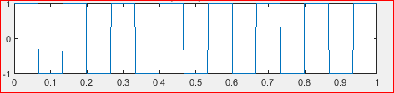

**Lab Grading Sheet :**

|  |  |  |  |
| --- | --- | --- | --- |
| **Task** | **Max Marks** | **Obtained Marks** | **Comments(*if any*)** |
| 1. | 5 |  |  |
| 2. | 5 |  |  |
| 3. | 5 |  |  |
| 4. | 5 |  |  |
| **Total** | **20** |  | **Signature** |

**Note : Attempt all tasks and get them checked by your Lab. Instructor**